Preface

XXX is a MatlabTM App to …

<*update field XXX* above to define model name throughout document using the *model_name* bookmark. This is a bookmark and needs to be added before cutting and pasting sections that use the bookmark. The header needs to be updated manually>

Requirements

The model is written in MatlabTM and provided as Open Source code (issued under a GNU General Public License) and runs under v2016b or later. XXX uses the muitoolbox and dstoolbox.

Resources

The XXX App and two toolboxes (muitoolbox and dstoolbox) can be downloaded from [www.coastalsea.uk](http://www.coastalsea.uk).

*Cite as*:

Townend, I.H., 2021, XXX manual, CoastalSEA, UK, pp9, [www.coastalsea.uk](http://www.coastalsea.uk).

Bibliography

Acknowledgements

Revision history

|  |  |  |
| --- | --- | --- |
| Version | Date | Changes |
| 1.0 |  |  |

Contents

1 Introduction 1

2 Getting started 2

2.1 Model Set-up 2

3 Application Menus 3

4 Implementation/Supporting Information/Demonstration models 4

5 Program Structure 5

6 Bibliography 6

# Introduction

XXX App …

# Getting started

<*insert ‘Sec2.1_Configuration.docx’ here using copy and paste (keep source formatting). The heading numbers and bookmarks should update*>

## Model Set-up

*File>New* to create a new project space.

*Setup>Input Data>Model Data*

The UI requests data for the model variables. Once added the current set of variables can be viewed using the *Inputs* tab.

*Run> Run model*

When the run has completed the user is prompted to provide a description of the model run (scenario).

The run is listed on the *Cases* tab and the tidal elevations for the most recent run can be viewed on the *Plot* tab.

*Plot>Plot menu*

The results from a run can be selected and plotted. By using the Add button additional model runs can be included on the plot, allowing different Cases to be compared.

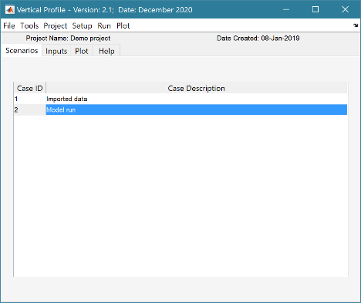

Default User Interface

Left click mouse on a Case to see the associated meta-data (as shown on the right)

# Application Menus

<*insert ‘Sec3.0_App_Menus.docx’ here using copy and paste (keep source formatting). The heading numbers and bookmarks should update*>

# Implementation/Supporting Information/Demonstration models

<*If required* *insert ‘Sec4.X_DeriveOutput.docx’ here using copy and paste (keep source formatting). The heading numbers and bookmarks should update*>

# Program Structure

<*insert ‘Sec5.0_Program_structure.docx’ here using copy and paste (keep source formatting). The heading numbers and bookmarks should update*>

# Bibliography